1. INTRODUCTION

1.1 Overview

A brief discussion about this project youtube THUMBNAIL.

1.2 Purpose

To entice potential viewers to want to see more .thumbnails let your audience view

a quick snapshot of your video.

1. Problem Definition /Design Thinking
   1. Empathy Map
   2. 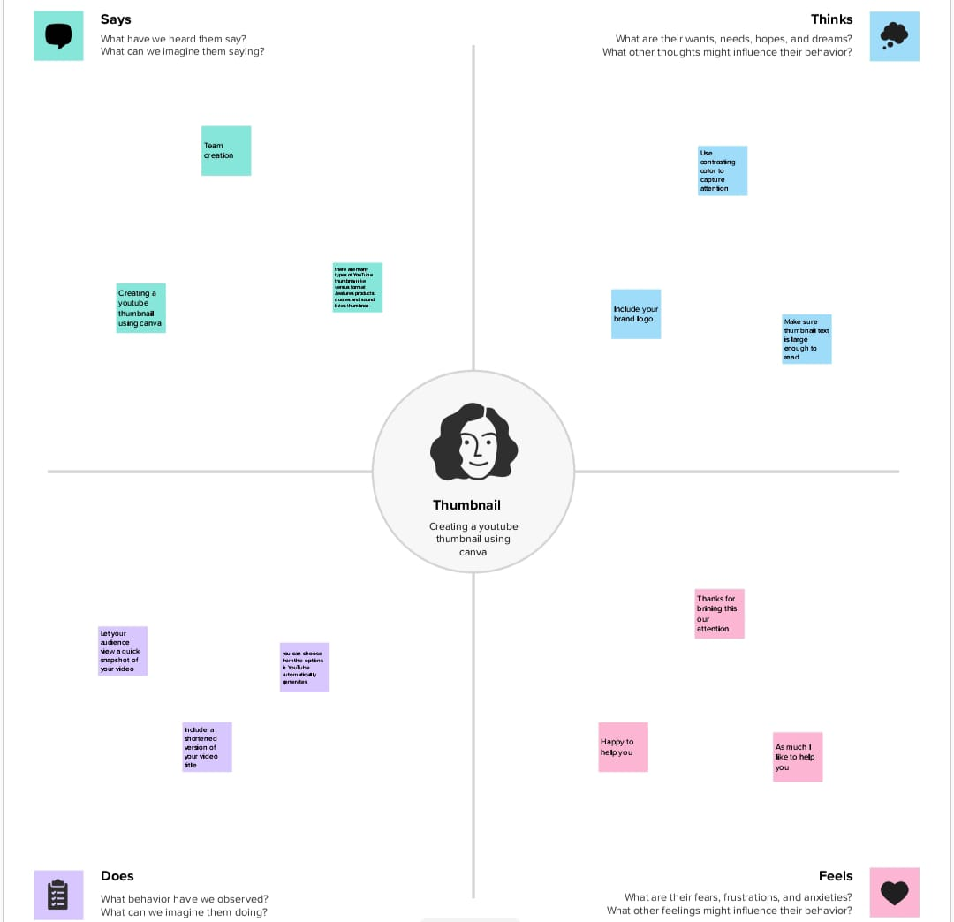

2.2 BRAINSTORMING MAP

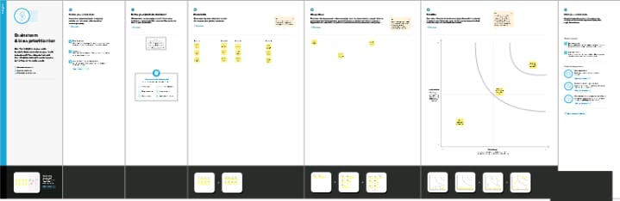

3.RESULT

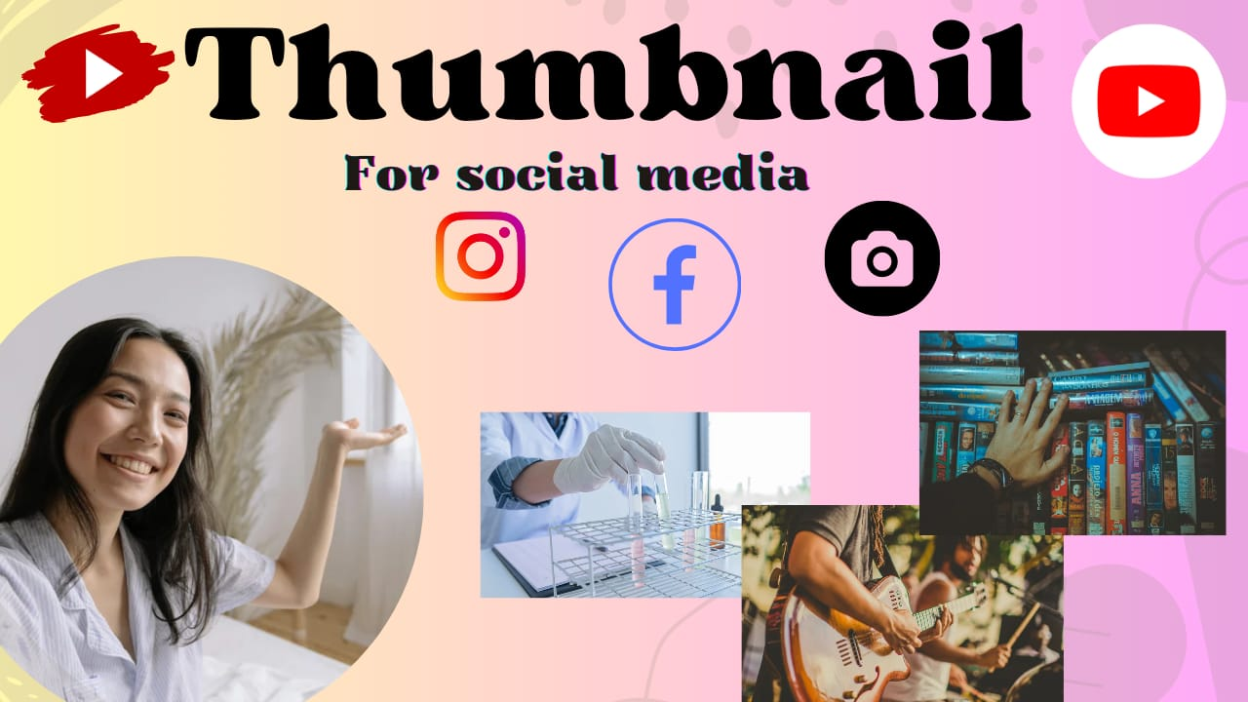

4 ADVANTAGES/DISADVANTAGES

Advantage

.The advantage of the YOUTUBE THUMBNAIL is allow your viewers to scan the video for content.

Disadvantage

.The disadvantage of YOUTUBE THUMBNAIL is extra time is required to design a YOUTUBE THUMBNAIL .

5. APPLICATIONS

So in this part , we have included some video thumbnail maker apps that you can use on iphone and android phones.

Canva

Wondershare

Pixstudio

Fotor

Fotojet

6. CONCLUSION

The conclusion of creating a YOUTUBE THUMBNAIL .A thumbnail is a small image representation of a larger image,usually intended to make it easier and faster to look at or manage a group of larger images.

7.FUTURE SCOPE

A well designed thumbnail can significantly increase the click through rate of your video,making it more likely for viewers to watch it .

8.APPENDIX

An appendix contains supplementary material that is not an essential part of the text itself but which may be helpful in providing a more comprehensive understanding of the research problem or it is information that is too cumbersome to be included in the body of the paper.